Dear Educators,

Many of you may know that children and teens sometimes experience stressful or traumatic events, whether at home or in the community, such as domestic violence, substance use, or crime. These experiences can weigh heavily on young minds, affecting their emotional and cognitive well-being. Unfortunately, many of these children silently carry this burden, even after returning to school. This stress often manifests as academic, emotional, or behavioral challenges that can significantly impact their ability to learn and thrive. This is where the Handle with Care initiative becomes crucial. It encourages us to recognize the signs of trauma and offer the understanding and support these children need. By being aware of their challenges, we can create a safe, compassionate environment where they can heal and thrive.

We are reaching out to share an initiative, which can make a meaningful difference in the lives of these children and help them succeed despite their struggles. The Handle with Care initiative is simple and powerful. When law enforcement encounters a child at the scene of an incident, a confidential notification is sent to the child’s school. This allows school personnel, like yourselves, to be prepared and equipped to observe and respond to any academic, emotional, or behavioral challenge the child may exhibit.

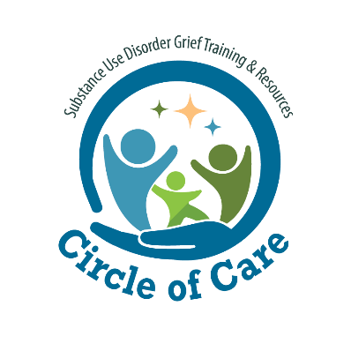Training and support are available to help you and your school implement this initiative. By adopting Handle with Care, you can ensure that children who have experienced trauma receive the understanding and support they need to succeed, not just in school but in life. If you are interested in training for your school personnel, please reach out to Teri Moore at [terim@hourhouserecovery.org](mailto:terim@hourhouserecovery.org).

Sincerely,

Teri Moore