**Handle with Care**

***Description of Handle with Care:***

* The Handle with Care program enables local law enforcement to notify school districts when they encounter a child at a traumatic scene so when that child arrives to school the next day, school staff and in some situations, mental health providers, can provide the child with support right away.

***Steps to Implementation:***

1. **Law enforcement encounter a child at a scene and send a message to the educators at the child’s school.**
   1. This can be done through sending a message to the school. The message could be sent by dispatch to either the School Resource Officer or the Regional Office of Education who would send the appropriate school the handle with care message
   2. The message can be sent via email, phone call/text, or 911 dispatch
   3. The message could be simply “Handle “child’s name” with Care”.
2. **Once the educators at the school receive the Handle with Care message, they will know that when that child shows up to school, they may need to provide trauma sensitive support.**
   1. These trauma-sensitive interventions can look like involving appropriate teachers and counselors to observe student behaviors/learning and to be prepared to provide trauma-sensitive support.
      1. Trauma sensitive support looks like: if a student acts out, the teacher can send them to see the counselor at the school, give them extra time on tests, reteach lessons, etc.
3. 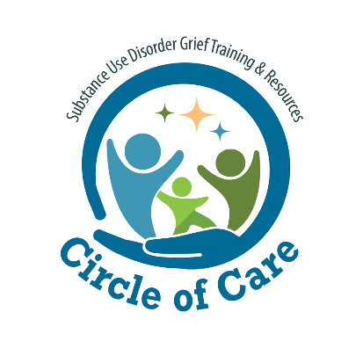**If a student continues to exhibit behavioral, emotional, or academic issues in the classroom, a school based mental health provider (such as a school counselor or school social worker) will determine if mental health services are appropriate for the child and can connect them with follow-up services.**

