Dear Law Enforcement Personnel,

As you know, children and teens sometimes experience stressful or traumatic events, whether at home or in the community, such as domestic violence, substance use, or crime. These experiences can weigh heavily on young minds, and unfortunately, many of these children must go to school afterward, carrying this burden of stress. This stress often manifests as academic, emotional, or behavioral challenges that can significantly impact their ability to learn and thrive. Unfortunately, educators may not always be aware of these incidents. This is where the Handle with Care initiative becomes crucial. It encourages us to recognize the signs of trauma and offer the understanding and support these children need. By being aware of their challenges, we can create a safe, compassionate environment where they can heal and thrive.

We are reaching out to you to share an initiative that can make a meaningful difference in the lives of these children and help them succeed despite their struggles. The Handle with Care initiative is *simple and powerful*. At the scene of an incident where a child is present, law enforcement will send a confidential notification to the child’s school or regional office of education. This enables school personnel to be prepared to observe and respond to any academic, emotional, or behavioral challenges the child may face.

Training and support are available to help you and your agency implement this initiative in your community. By adopting Handle with Care, you can ensure that children who have experienced trauma receive the understanding and support they need to succeed, not just in school, but in life. Reach out to Office Doug Cochran at 217-712-0172 for more information and guidance on how to implement Handle with Care in your area.

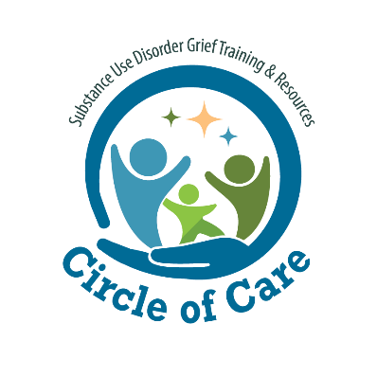Sincerely,

Officer Doug Cochran

*Kansas Police Department*

*Handle with Care Liaison*